Lalleshwari - An Apostle Of Human Values
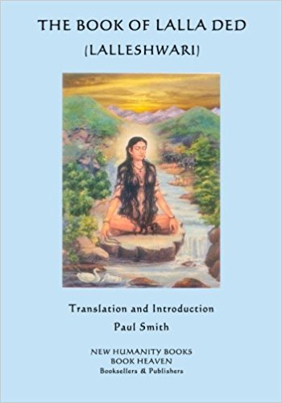

Prof. K. N. Dhar

The cultural heritage of a country secures sustenance from the philosophy of life nurtured by its people from the time man awoke to consciousness of self and spirit. This search for spiritual values can in no way be the last word at any stage since such pursuits are cumulative in character and content; this edifice comes into being steadily, hammered into proper shape by savants and saints from time to time. However, it calls for re-interpretation every day so that the erring human being, with all his frailties, does not descend to animality. This is the veritable theme of Lord Krishna's message in Bhagwad Gita. In our happy valley Lalleshwari projected such human values so dear to Kashmiris from the dawn of history.

Conciliation

An attitude of conciliation, instead of confrontation, can be gleaned from the pages of Nilamata Purana wherein Lord Buddha has been acknowledged as an incarnation of God-Avatara.1 'Bud­dhism was essentially arevolt against Brahminism. Yet, the catholic Brahmin, with his proverbial forbearance, did not use the same language or adopt the same attitude as the Buddhists had employed with respect to Brahminism. The heal thy approach of Kashmiri Brahmins was never negative in essence. In this connection, we can safely assert that Lalleshwari, a vigilant sentinel of Kashmiri culture, displayed the highest mag­nitude of courage and foresight in those not very auspicious times, beckoning man not to discriminate on the basis of religious labels : It was actually the continuation of that catholic attitude of mind displayed by Kashmiris from time immemorial.

Capricious Time

However, time does not maintain a uniform tenor or temper; it is at times moody and capricious. And when the political map of Kashmir was redrawn in the thirteenth-fourteenth century, by the induction of Sultans over the Kashmir scene, this accommodation of head and heart received a jolt.2 Kashmiris became oblivious of their pristine past; the present consequently got divorced from it, multilating its brilliant face and its attendant decorum. During those unsavoury times, Lalleshwari, fortified to her marrow by the innate strength other conviction, rose to the occasion and strove hard to put to an end a dismal em of persecution and vandalism. In this crusade her tools were not abjuration, but affirmation; bitterness changed hands with sweet and more persuasive compromise. Having elected to tread this path of self-suffering, she became a model for the millions of her countrymen to abjure the mundane and propitiate the sublime. It was no less than a miracle by which the sufferings of the people lost their sting and they learnt to bear these with stoical resistance. They were exhorted to rise above the self and reach up to the super-self at which stage pleasure or pain have no relevance or meaning.3 Some say it was self-deceit, fleeing from the actual life, nither self-forgetfulness to feel shy of the stark realities of life. The most apt answer to this faulty assertion is provided by ever-awake Lalleshwari herself in these words :

Some may heap cavil on me, even some may curse me; they may say whatever they like to say. Some may worship me with the flowers of inherent cognition, yet I do not feel ruffled with this kind of impeachment or praise since I am concerned with my own self and do not grudge what others have to say about me.

Muslim Rule

During the Muslim rule over Kashmir the propagation of San­skrit was not encouraged, Bilhana, the famous lyricist of Kashmir, had once boasted that "in their household, Kashmiri women even speak Sanskrit and Prakrit as fluently as their mother-tongue".5 It was now an old wooden story. However, a bridge was to be built between the present and the past for which Sanskrit had been a very potent instrument; but the general public had lost contact with it. Persian was the order of the day in its stead. So Lalleshwari chose to speak to the people in their own idiom and Kashmiri became the vehicle of her message. In this way, she did not only make her message more intelligible and comprehensive to the masses but also achieved the purpose of bridging the gulf between the past and the present.

Healing Touch

In her time the friction between the past and the present was acute; hence she, like an alchemist, by her healing touch, saved Kashmiri culture from being eroded and bruised. Her clarion-call to assimilate human values in those dark days won for her the esteem and acclaim of Hindus and Muslims alike. It was no mean achieve­ment on her part to unite the lost children of God, when every effort was being made to segregate them from one another. Her message was so universal and appealing that the tallest of Muslim Rishis of Kashmir, Sheikh Noor-ud-Din N

